# LAB 5

# SIMPLE TASK:

1. Write a program that asks the user to type the value of N and computes N!. The factorial of a positive integer number is mathematically written as n! and is the product of all numbers from 1 to n. N! = 1*2*3*…..n.

Code:

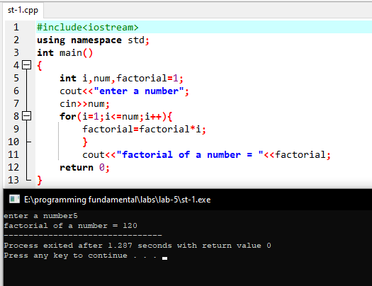

2. Two numbers are entered through the keyboard. Write a program to find the value of one number raised to the power of another.

Code:

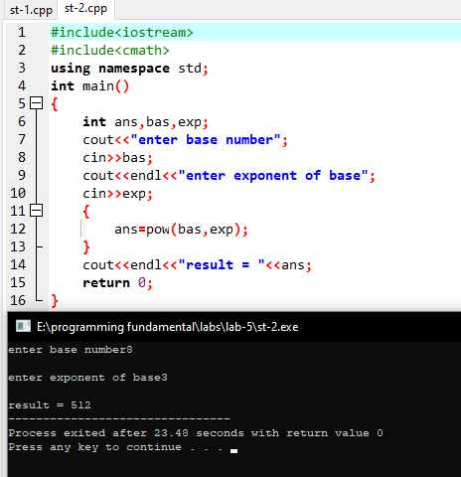

3. Write a C++ program to print following pattern:

**********

**********

**********

**********

Code:

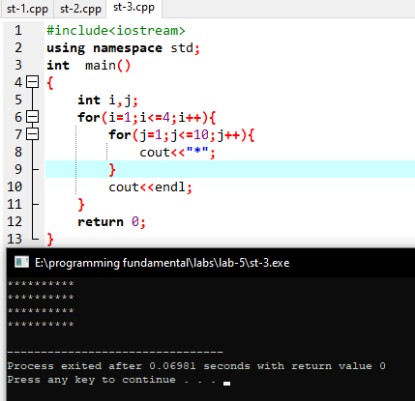

## CHALLENGING TASK:

1 . Write a program to check given number is prime or not.

code:

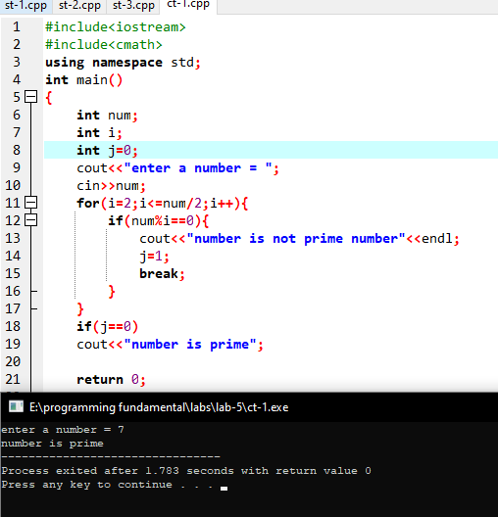

2 . Write C++ program to print following pattern:

*

**

***

****

*****

Code:

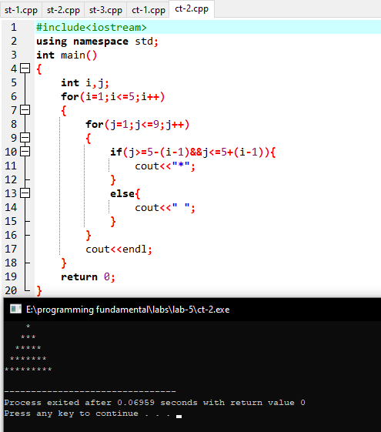

### HOME TASK:

1 . Write C++ program to print following pattern:

1

222

33333

4444444

555555555

Code:

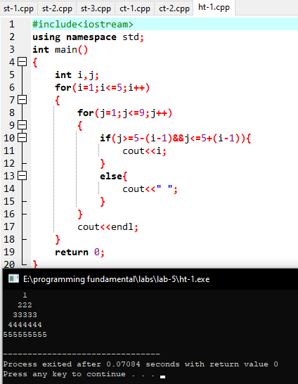

2 . Write a program to compute the cosine of x. The user should supply x and a positive integer n. We compute the cosine of x using the series and the computation should use all terms in series up through the term involving xn.

cos𝑥 = 1 − 𝑥2/2! + 𝑥4/4! + 𝑥6/6! …

code:

